Why Access Control? It focuses our work so that we do not become overwhelmed by the vast number of webpages.
What do people see if they do not have access? A message that says
How do I turn on Access Control? Access Control is applied to each webpage separately.
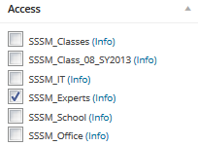
For example the webpage http://www.torontoarmenianchurch.com/sssm-it-committee is controlled by
This means that only accounts belonging to the SSSM_Experts Access Room can access that webpage.
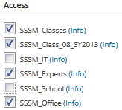
Another example, a webpage with more checkmarks means that more people can access it.

What is an Access Room? It is a convenient name given to many users who access the same webpages. It’s like calling “everyone from the Grade 8 classRoom”.
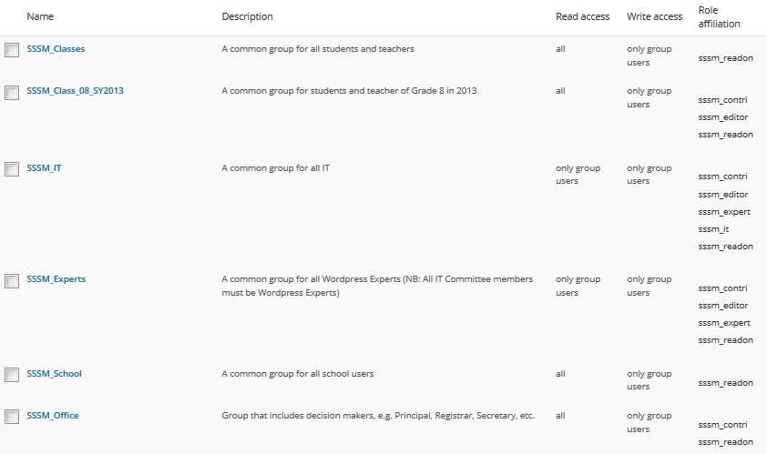
What if I forget to check any Access Room? Then Wordpress allows everyone access to that particular webpage! Therefore in order to limit access, you must check at least 1. If nothing is checked, it is like turning off Access Control.
How many Access Rooms are there? Here they are (We need to add more classrooms. This list is incomplete.)

Please give us a clue who is in each Access Room?
Access Rooms are modeled after the physical rooms in the school. For example:
SSSM_Office = Arpi, Armineh, All Teachers, All Students
SSSM_School = Everyone

SSSM_Classes = All Teachers, All Students
SSSM_Class_08_SY2013 = Grade 8 Teacher, Grade 8 Students

SSSM_Experts = Arpi, Armineh, Alex, Hrad
SSSM_IT = Alex, Hrad

Wait! If everyone has access to the SSSM_School then does that mean that everyone can modify that webpage? Great question! I see you are thinking and understanding. There is one more piece to the puzzle called an Access Role.
What is an Access Role? It describes each user’s comfort level. For example a student may have access to read the office webpages; whereas Armineh has access to modify the office webpages.
So in summary: Access Rooms map the SSSM website, Access Control is where you are allowed to go, and Access Role is what you can do when you get there.

